**--Full Adder – Behavioral Model**

**1. Code**

**----------------------------------------------------------------------------------**

library IEEE;

use IEEE.STD_LOGIC_1164.ALL;

use IEEE.STD_LOGIC_ARITH.ALL;

use IEEE.STD_LOGIC_UNSIGNED.ALL;

entity FULL_ADDER1 is

Port ( a,b,c : in STD_LOGIC;

s,cr : out STD_LOGIC);

end FULL_ADDER1;

architecture Behavioral of FULL_ADDER1 is

begin

process (a,b,c)

begin

if (a='0' and b='0' and c='0' ) then

s <= '0';

cr <= '0';

elsif (a='0' and b='0' and c='1' ) then

s <= '1';

cr <= '0';

elsif (a='0' and b='1' and c='0' ) then

s <= '1';

cr <= '0';

elsif (a='0' and b='1' and c='1' ) then

s <= '0';

cr <= '1';

elsif (a='1' and b='0' and c='0' ) then

s <= '1';

cr <= '0';

elsif (a='1' and b='0' and c='1' ) then

s <= '0';

cr <= '1';

elsif (a='1' and b='1' and c='0' ) then

s <= '0';

cr <= '1';

else

s <='1';

cr <='1';

end if ;

end process ;

end Behavioral;

**2. RTL schematic**

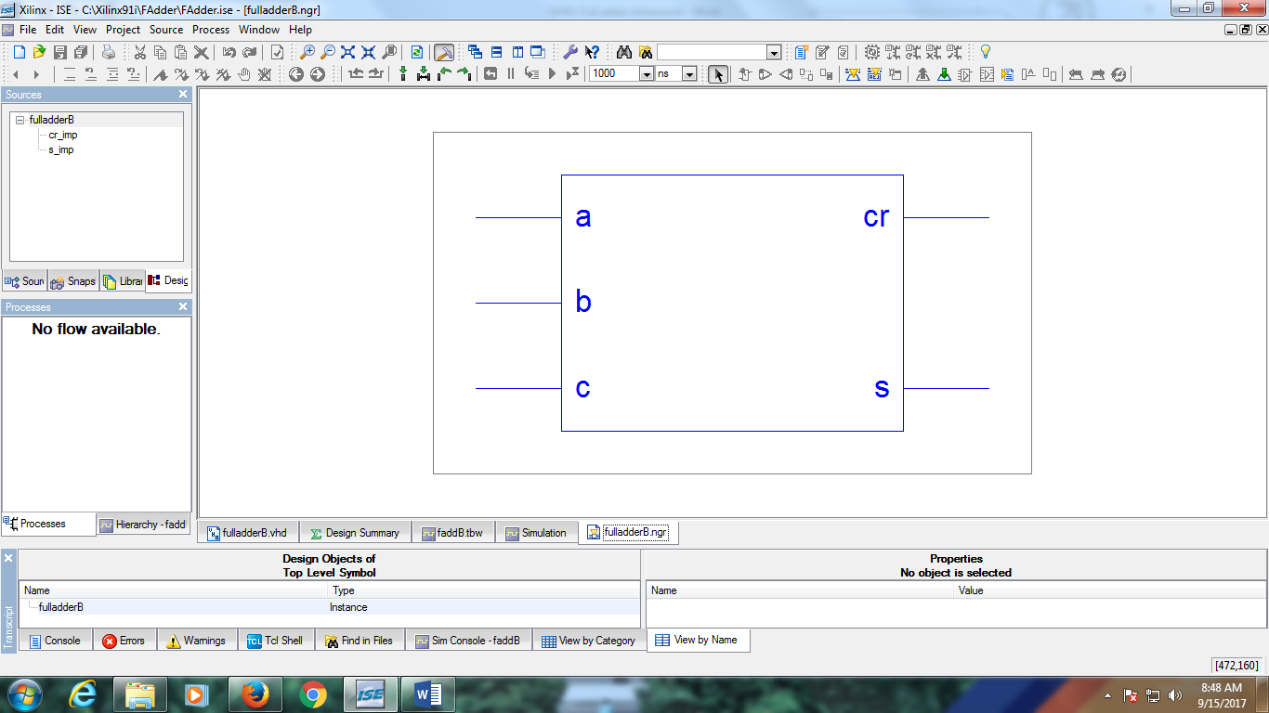

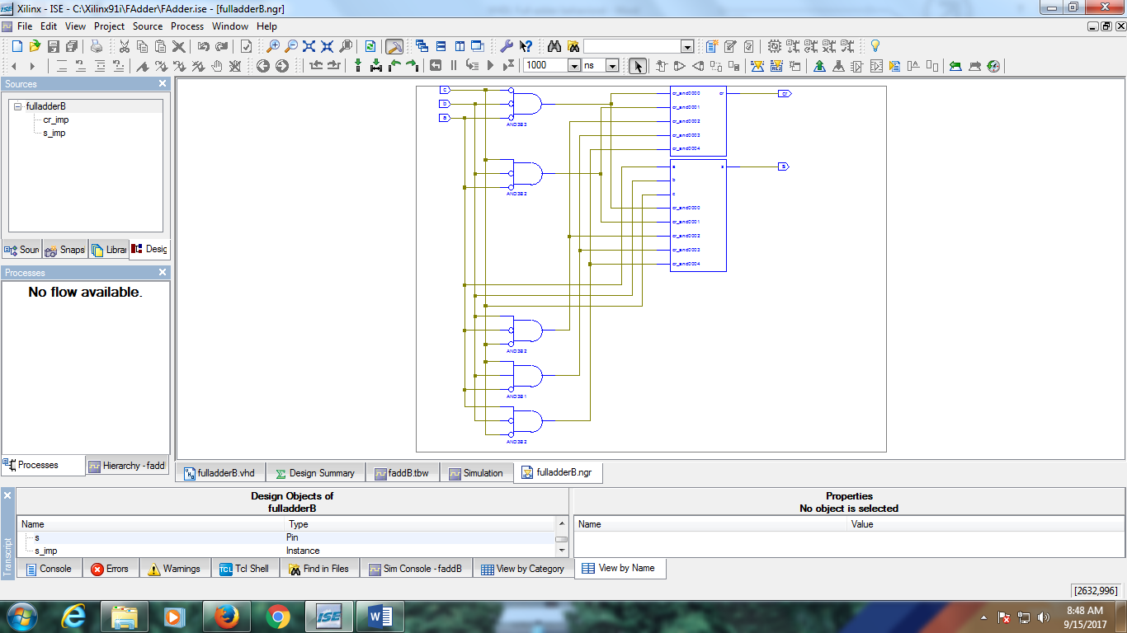

**3. Simulation Output**

